ORDER FORM - please fax or email this form together with your deposit slip to: email info@reboundsa.co.za or Fax on 0866 98 99 40

DESCRIPTION |  | Unit price | Quantity | Total
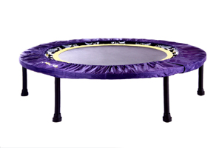
REBOUNDER (Two-fold: they fold in half) with book and DVD
 | HEALTHBOUNCEPRO (Recommended user weight from 25kg to max 130kg)  Includes FREE: Digital DVD 1&2 Compilation and The Miracle Exercise | R2250
OPTIONAL ACCESSORIES
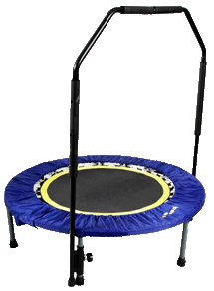  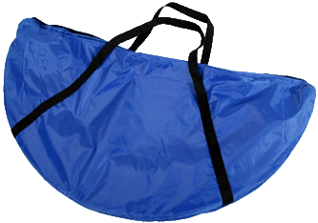 | Canvas Carry Bag | R200
 | Support bars Removable, adjustable support bars. Recommended for people with compromised balance, recovering from injury and illness and the frail. | R300
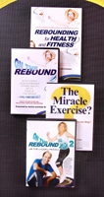
BOOK & DVD’S
 | Rebounding for Health and Fitness BOOK 160 page soft cover book by Keith and Justine McFarlane | R150
 | On the Rebound Compilation - DVD 1 and DVD2 2 x 40 min sessions  Physical DVD | R150
 | “The Miracle Exercise?” DVD 3 information, instruction, Mind Power and quick 2 – 5 min sessions. Running time 60 minutes Physical DVD | R150
 | Essential Health Protocols  An End to All Disease  The Eightfold Pathway  The Little Big Book of Health | R60  R60  R180  R90
SPARE PARTS
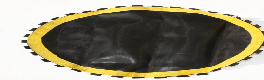 | Replacement Mats (please mark whether 36 spring unit or 32 spring unit) | R300
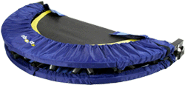 | Replacement Skirts | R300
 | Mat Springs (set of 6) Individual springs R20 each | R100
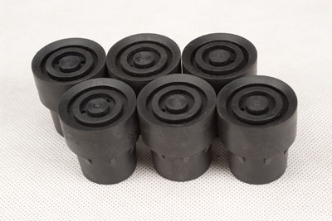 | Rubber leg shoes R20 each | R20

DELIVERY OPTIONS Please see our “DELIVERY GUIDE” page for area maps, prices per area, options & details - Exclude this section if you are collecting from ReboundSA in JHB (NB: Price per rebounder)
1. National SA  Post Office | (includes up to 4 books/DVD’s) Delivery 4 – 5 w/days. | R220
1. National SA  Post Office | Books & DVD’s up to 3 books or DVD’s, delivery 4 – 5 w/days. | R85
2. JHB Courier | 24 hours (weekdays) Door-to-door courier delivery in the JHB area | R90
PTA Courier | 1 – 2 working days for door-to-door courier delivery to Midrand, PTA East and West & up to Roslyn & Zambezi drive. | R100
Gauteng Surrounding | Please see the yellow area on map for Gauteng Surrounding areas included | R130
3. Cape Courier | 3 – 4 working days door-to-door courier delivery to W/Cape (please see map) | R140
PE/East London | 3 – 4 working days door-to-door courier delivery to these Major cities | R140
4. KZN Courier | 2 – 3 working days door-to-door courier delivery to KZN (please see map) | R130
Bloemfontein/  Nelspruit | 2 – 3 working days door-to-door courier delivery to these Major cities | R130
5. Other Cities | Courier to MAJOR towns not listed on the map | R150
Outlying | Courier to small towns outlying areas– please call for a quote (post office usually recommended)

Total for Rebounder and/or books, DVD’s and Delivery |  | R
NAME | DATE | ReboundSA  STD Bank  Branch: The Glen  Branch Code: 006005  Ac. 041 146 867
DELIVERY ADDRESS If applicable, include any special delivery instructions.

Post Code
Tel Email

(Landline and Cell if possible)

COURIER & POST OFFICE DELIVERY - AREAS & RATES

Collection or delivery options – you can either:
1) Collect your rebounder from our office in Glenvista/ just South of JHB (contact us for directions),
2) Send your own courier or driver to collect
3) We can deliver by Door-to-Door Courier (takes 1 – 3 working days, depending on area)
4) or Counter-to-Counter insured post to any South African Post Office (takes 4 – 5 working days).

Please see below for rates and areas and feel free to contact us if:
1) You need any further information or if you are unsure about the rates or options for your area
2) You are sending more that 1 parcel to area’s outside of those shown in the diagrams (green box at the bottom of the page) as courier rates for more than 1 parcel to these areas are usually reduced)
1. POST OFFICE NATIONAL COUNTER TO COUNTER INSURED PARCEL DELIVERY
a) 1 – 3 small items (books or DVD’s in 1 bubble wrap envelope) R85
b) 1 Rebounder (this parcel can include a rebounder and/or bar, and up to 4 books and/or DVD’s) R220
Delivery of all insured Post Office parcels takes between 4 – 5 working days

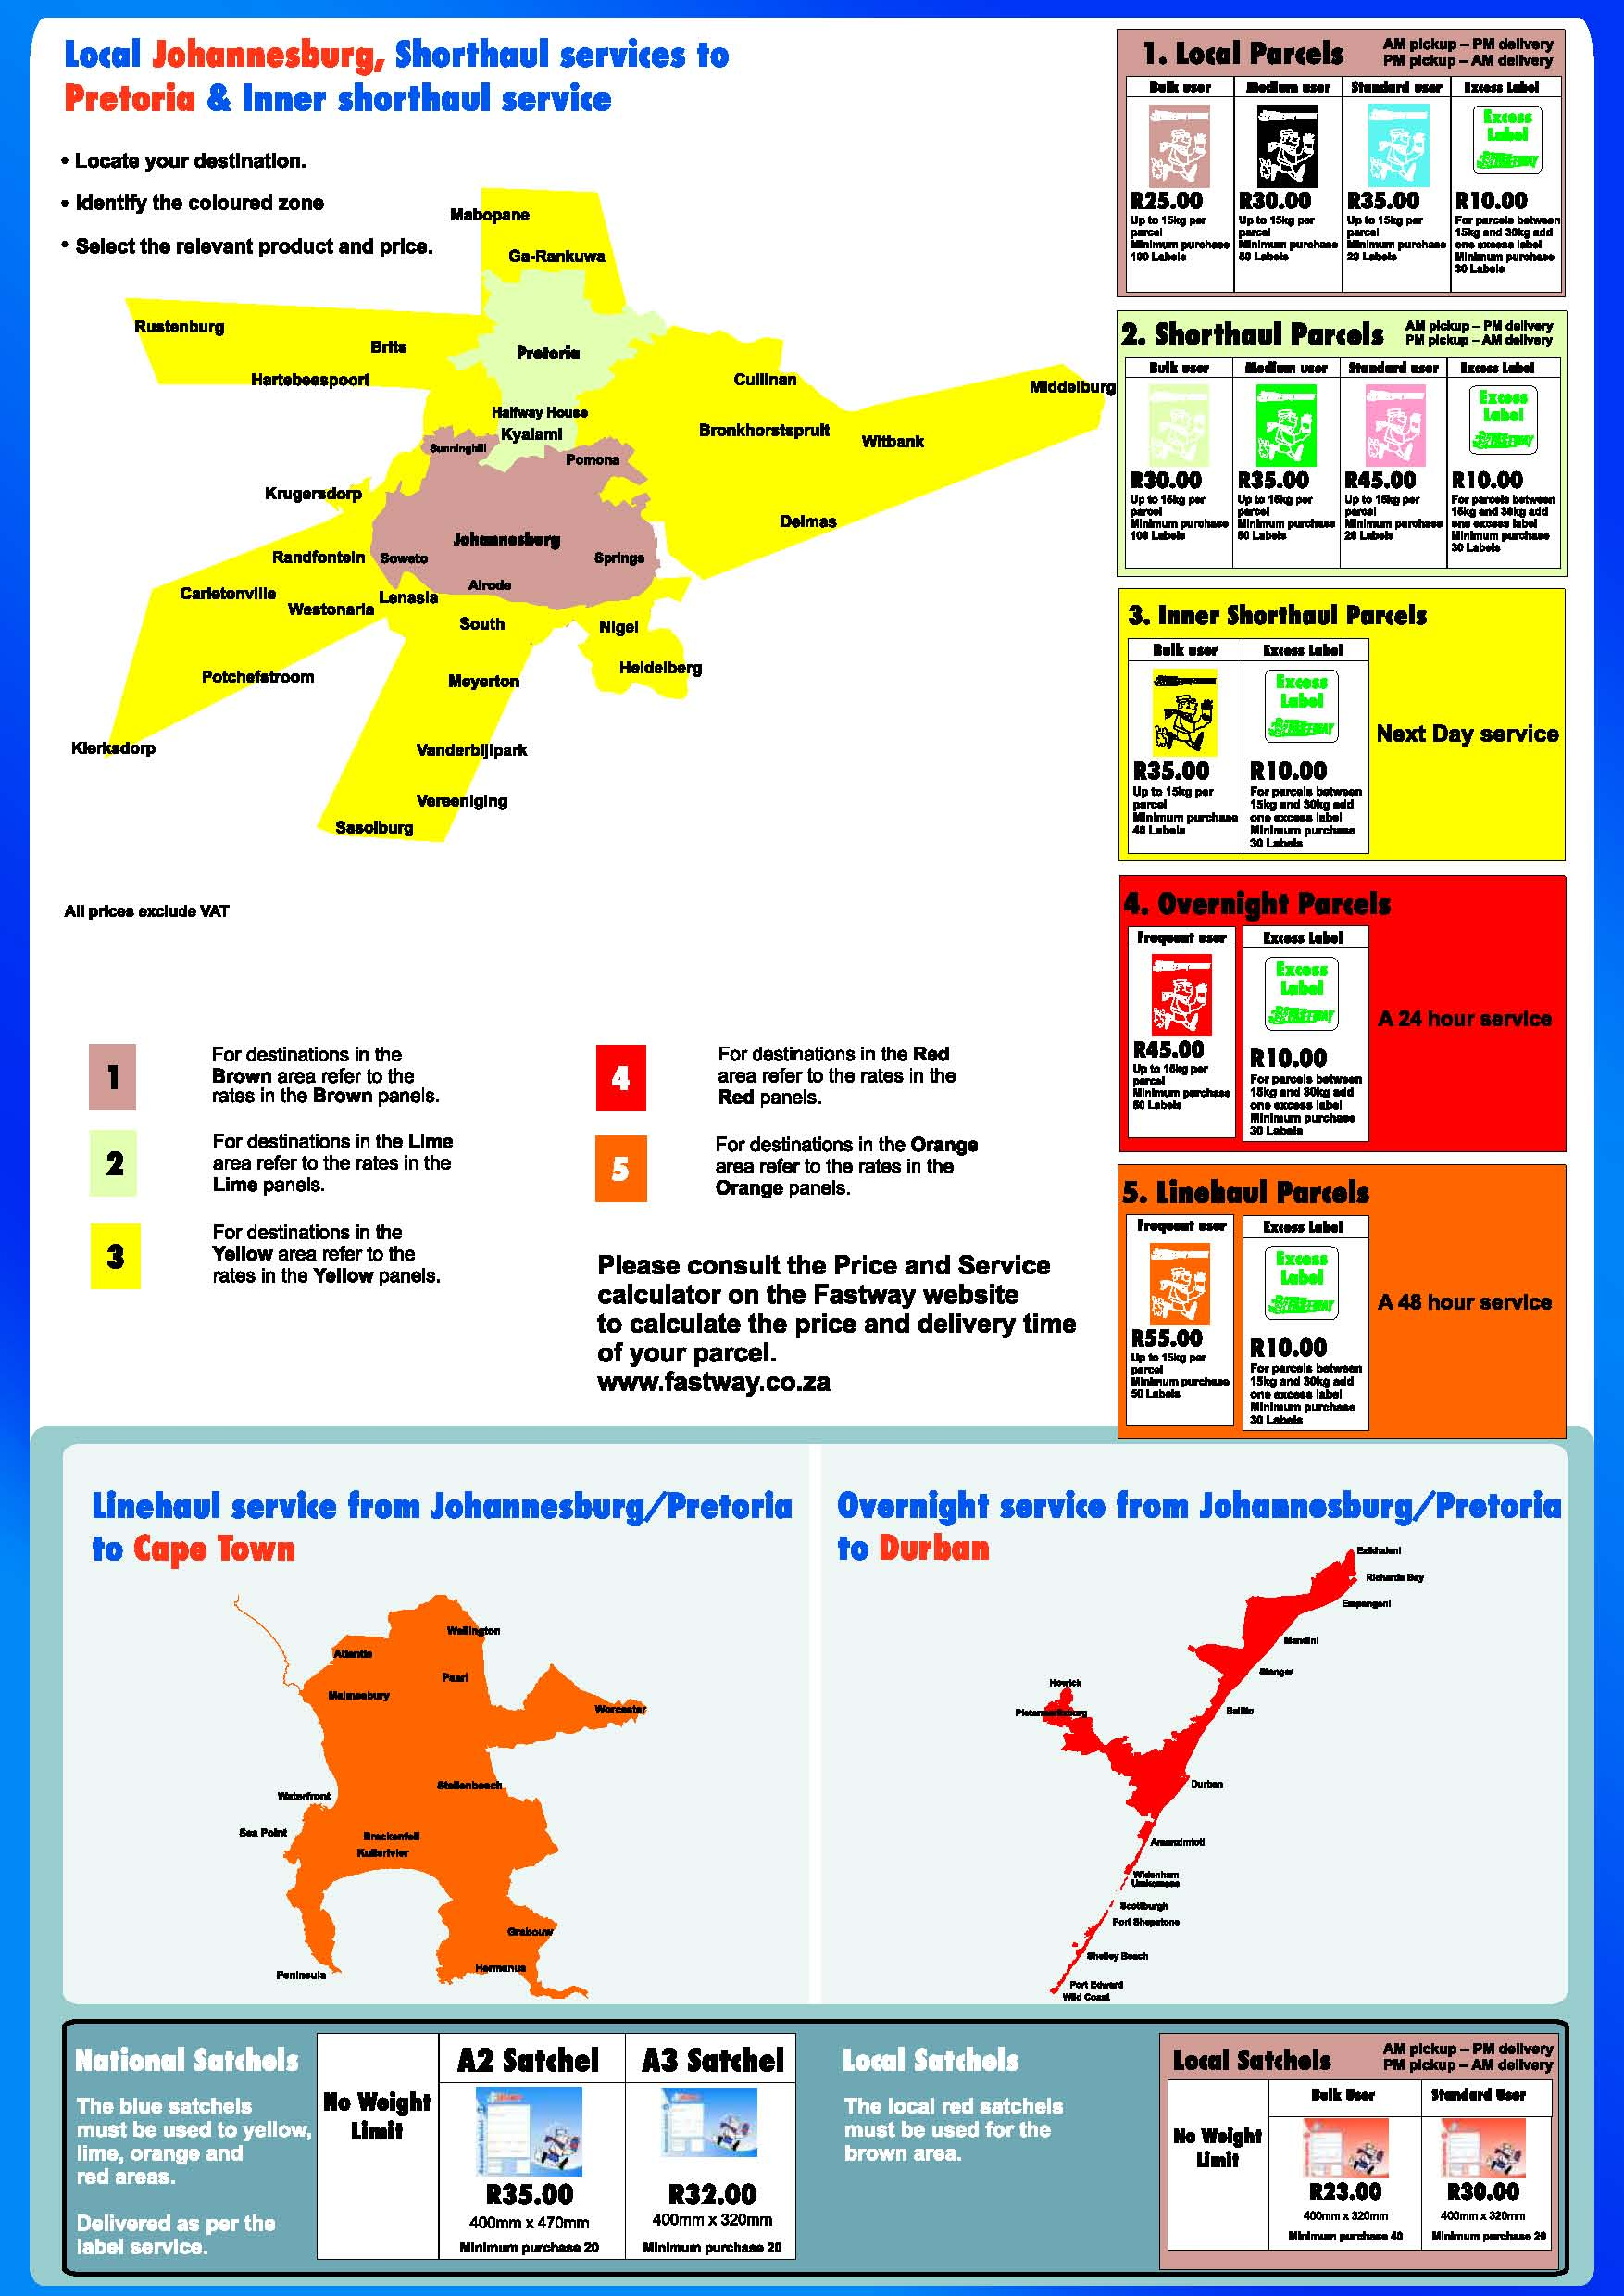
DELIVERY TO JOHANNESBURG, PRETORIA,
AND SURROUNDING AREAS

2. COURIER

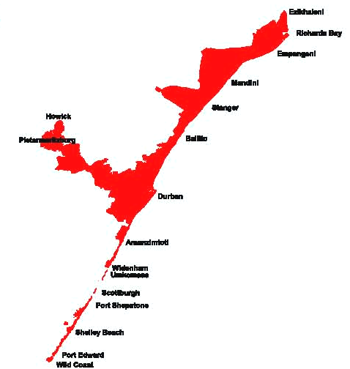

3.COURIER TO CAPE TOWN &
SURROUNDING

R140

Door-to-door Delivery
takes 2 – 3 work days
and is to all areas within
the orange block. Prices
are per parcel and can
include 1 x rebounder
and/or books/DVD’s,
carry bag & support bars.

4. COURIER TO
DURBAN & KZN
COASTLINE

R130

Delivery takes
1 - 2 working days
and is to all areas
within the red block.
Prices are per parcel and
can include 1 x rebounder
and/or books/DVD’s, carry
bag and support bars.

5. COURIER FOR ALL OTHER AREAS NOT LISTED ABOVE (NORTHERN AND WESTERN CAPE, FREE STATE, MPUMALANGA, LIMPOPO, ETC)
Door to door courier delivery to MAJOR towns & cities (not included above) per rebounder & up to 3 books or DVD’s R150
Door-to-door delivery to outlying areas and smaller towns, please call us for a quote. We usually recommend post office delivery (R220) to these outer areas (courier can be anything between R160 – R360)

Johannesburg R90

Pretoria R100
Outlying JHB/Pretoria R130
Door-to-door courier delivery
Takes 1 – 2 working days to all areas within brown, green & yellow colour grids. Prices are per parcel which can include 1 x rebounder and/or books/DVD’s, carry bag & support Bars .

