ORDER FORM - please fax or email this form together with your deposit slip to: email info@reboundsa.co.za or Fax on 0866 98 99 40

DESCRIPTION |  | Unit price | Quantity | Total
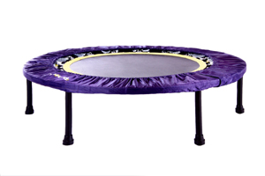 REBOUNDER (Two-fold: they fold in half) with book and DVD
 | HEALTHBOUNCEPRO (Recommended user weight from 25kg to max 130kg)  Includes FREE: Digital DVD 1&2 Compilation and The Miracle Exercise | R2400
OPTIONAL ACCESSORIES
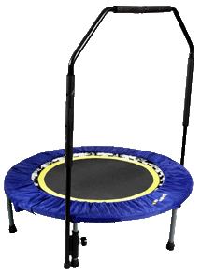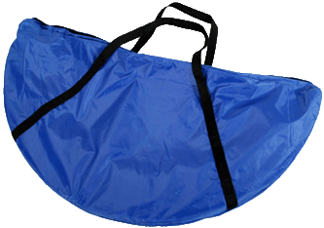 | Canvas Carry Bag | R300
 | Support bars Removable, adjustable support bars. Recommended for people with compromised balance, recovering from injury and illness and the frail. | R400
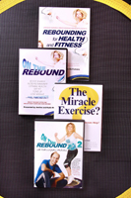 BOOK & DVD’S
 | Rebounding for Health and Fitness BOOK 160 page soft cover book by Keith and Justine McFarlane | R150
 | On the Rebound Compilation - DVD 1 and DVD2 2 x 40 min sessions  Physical DVD | R120
 | “The Miracle Exercise?” DVD 3 information, instruction, Mind Power and quick 2 – 5 min sessions. Running time 60 minutes Physical DVD | R120
 | Essential Health Protocols  An End to All Disease  The Eightfold Pathway  The Little Big Book of Health | R60  R60  R180  R90
SPARE PARTS
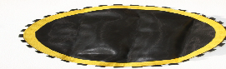 | Replacement Mats (please mark whether 36 spring unit or 32 spring unit) | R350
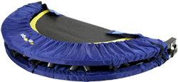 | Replacement Skirts | R350
 | Mat Springs R20 each | R20
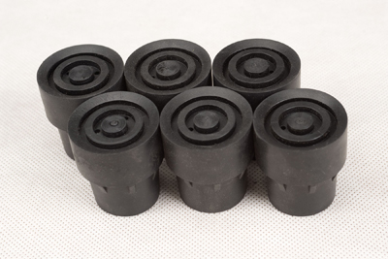 | Rubber leg shoes/ Leg Springs R20 each | R20

DELIVERY OPTIONS Please see our “DELIVERY GUIDE” page for area maps, prices per area, options & details - Exclude this section if you are collecting from ReboundSA in JHB (NB: Price per rebounder)
1. SA Post Office  PO or Courier | (includes up to 4 books/DVD’s) Delivery 4 – 5 w/days. | R220
 | Books & DVD’s up to 3 books or DVD’s, delivery 4 – 5 w/days. | R90
2. JHB Courier | 24 hours (weekdays) Door-to-door courier delivery in the JHB area | R100
PTA Courier | 1 – 2 working days for door-to-door courier delivery to Midrand, PTA East and West & up to Roslyn & Zambezi drive. | R110
Gauteng Surrounding | Please see the yellow area on map for Gauteng Surrounding areas included | R140
3. Cape Courier | 3 – 4 working days door-to-door courier delivery to W/Cape (please see map) | R150
PE/East London | 3 – 4 working days door-to-door courier delivery to these Major cities | R150
4. KZN Courier | 2 – 3 working days door-to-door courier delivery to KZN (please see map) | R140
Bloemfontein/  Nelspruit | 2 – 3 working days door-to-door courier delivery to these Major cities | R150
5. Other Cities | Courier to MAJOR towns not listed on the map | R175
Outlying | Courier to small towns outlying areas– please call for a quote (post office usually recommended)

Total for Rebounder and/or books, DVD’s and Delivery |  | R
NAME | DATE | ReboundSA  STD Bank  Branch: The Glen  Branch Code: 006005  Ac. 041 146 867
DELIVERY ADDRESS If applicable, include any special delivery instructions.

Post Code
Tel Email

(Landline and Cell if possible)

COURIER & POST OFFICE DELIVERY - AREAS & RATES

Collection or delivery options – you can either:
1) Collect your rebounder from our office in Glenvista/ just South of JHB (contact us for directions),
2) Send your own courier or driver to collect
3) We can deliver by Door-to-Door Courier (takes 1 – 3 working days, depending on area)
4) or Counter-to-Counter insured post to any South African Post Office (takes 4 – 5 working days).

Please see below for rates and areas and feel free to contact us if:
1) You need any further information or if you are unsure about the rates or options for your area
2) You are sending more that 1 parcel to area’s outside of those shown in the diagrams (green box at the bottom of the page) as courier rates for more than 1 parcel to these areas are usually reduced)
1. POST OFFICE NATIONAL COUNTER TO COUNTER INSURED PARCEL DELIVERY
a) 1 – 3 small items (books or DVD’s in 1 bubble wrap envelope) R90
b) 1 Rebounder (this parcel can include a rebounder and/or bar, and up to 4 books and/or DVD’s) R220
Delivery of all insured Post Office parcels takes between 4 – 5 working days

2. COURIER

DELIVERY TO JOHANNESBURG, PRETORIA,
AND SURROUNDING AREAS

4. COURIER TO
DURBAN & KZN
COASTLINE

R140

Delivery takes
1 - 2 working days
and is to all areas
within the red block.
Prices are per parcel and
can include 1 x rebounder
and/or books/DVD’s, carry
bag and support bars.
3.COURIER TO CAPE TOWN &
SURROUNDING

R150

Door-to-door Delivery
takes 2 – 3 work days
and is to all areas within
the orange block. Prices
are per parcel and can
include 1 x rebounder
and/or books/DVD’s,
carry bag & support bars.

5. COURIER FOR ALL OTHER AREAS NOT LISTED ABOVE (NORTHERN AND WESTERN CAPE, FREE STATE, MPUMALANGA, LIMPOPO, ETC)
Door to door courier delivery to MAJOR towns & cities (not included above) per rebounder & up to 3 books or DVD’s R175
Door-to-door delivery to outlying areas and smaller towns, please call us for a quote. We usually recommend post office delivery (R220) to these outer areas (courier can be anything between R160 – R360)

Johannesburg R100

Pretoria R110
Outlying JHB/Pretoria R140
Door-to-door courier delivery
Takes 1 – 2 working days to all areas within brown, green & yellow colour grids. Prices are per parcel which can include 1 x rebounder and/or books/DVD’s, carry bag & support Bars .

